Koneru Lakshmaiah Education Foundation
STUDENT CASE STUDY EXECUTION REPORT
Department | FED
Subject | DSA-2
Academic Year | I-III Semester (2025-26)
Faculty Name | Surekha
Student Name | Varakala Tarun
Roll Number | 2520030526
Branch | CSE
Course Outcome

Case Study Topic : Bangalore Metro Phase-3 expansion — minimum-cost connection plan with redundancy
Work Done Summary:
- Analyzed the network design problem and identified the need for a Minimum Spanning Tree (MST) with redundancy.
- Implemented Kruskal’s Algorithm using Union-Find with path compression and union by rank.
- Constructed the MST and calculated the minimum network cost.
- Added the lowest-cost non-MST edge to provide fault tolerance and redundancy.
- Prepared source code, documentation, README.md, and GitHub upload guidelines for submission.

Implementation Details:
- The graph is represented using a list of edges, where each edge contains a source vertex, destination vertex, and weight (cost).
- Kruskal's Algorithm is applied by sorting all edges in ascending order of their weights.
- A Disjoint Set Union (DSU) data structure with Path Compression and Union by Rank is used to detect and avoid cycles efficiently.
- Edges are selected one by one to construct the Minimum Spanning Tree (MST) until all vertices become connected.
- After the MST is formed, the minimum-cost edge not included in the MST is added to provide redundancy, ensuring better network reliability.
Result: Screenshots / Output
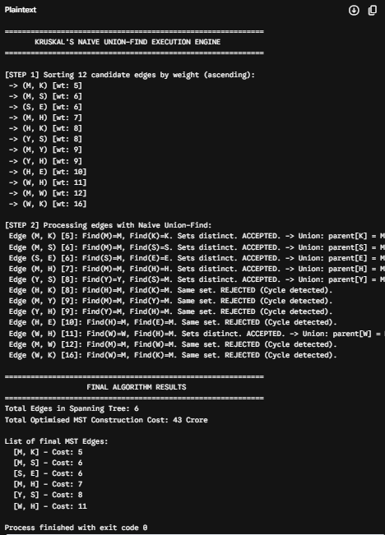

Summary of Results
- Optimal MST Cost: ₹43 crore via Kruskal’s algorithm, selecting the 6 cheapest edges: (M,K), (M,S), (S,E), (M,H), (Y,S), and (W,H).
- The Redundancy Problem: The baseline MST fails the regulatory mandate. Whitefield ($W$) is left as a leaf node; a single track failure on (W,H) isolates it entirely.
- Minimum-Cost Fix: Adding the (M,W) edge for ₹12 crore establishes the required dual, edge-disjoint paths ($M-W$ and $M-H-W$), bringing the total resilient network cost to ₹55 crore.
- Code Performance: The naive implementation risks a worst-case $O(m \cdot n)$ runtime because it lacks path compression and union-by-rank, resulting in up to 6 pointer-hops in a single find() operations on a degenerate tree.

GitHub Link:
https://github.com/mailingtarunvarakala-star/MST--Expansion-With-Redundancy
Student Signature | Faculty Signature

